SIMATS ENGINEERING

***CAPSTONE PROJECT REPORT***

**PROJECT TITLE**

**AI POWERED REAL TIME EMOTION DETECTION USING WEBCAM**

***CSA1759-ARTIFICIAL INTELLIGENCE FOR EXPERTS***

*Submitted by*

P.Nikhil

(192211587)

Ch. Eswar

(192210671)

*Under the supervision of*

Dr. ROHITH BHAT

*Department of Computer Science and Engineering*

**DECLARATION**

We, Nikhil and Eswar, are the students of Bachelor of Engineering in the Department of Computer Science and Engineering, Saveetha Institute of Medical and Technical Sciences, Saveetha University, Chennai. We hereby declare that the work presented in this Capstone Report for the Artificial Intelligence course (CSA1759) entitled “” is the outcome of our own work and is correct to the best of our knowledge and understanding.

P.Nikhi(192211587) Ch. Eswar (192210671)

**Date: 26/11/2024**

**Place: Chennai**

**ABSTRACT**

Real-time face detection has become a critical component in various applications, ranging from security systems to entertainment and human-computer interaction. This project, titled *"Real-Time Face Detection Using Webcam,"* harnesses the power of modern machine learning frameworks such as TensorFlow and computer vision libraries like OpenCV to enable efficient and accurate face detection. Additionally, the inclusion of Deepfake detection mechanisms enhances the system's capabilities by identifying and mitigating the risks associated with manipulated or synthetic facial content.

The system integrates OpenCV for preprocessing tasks, including capturing video frames from the webcam, image resizing, and gray-scaling to optimize input data. TensorFlow is employed to leverage deep learning models trained on large-scale datasets for robust face detection, ensuring the system's reliability under diverse lighting conditions, facial orientations, and occlusions. Furthermore, the integration of a Deepfake detection module adds a layer of security by identifying digitally altered faces, a growing concern in digital and social media platforms.

Key objectives of the project include achieving high-speed frame processing to ensure real-time performance, maintaining a high detection accuracy rate, and minimizing false positives and negatives. The system's architecture comprises a cascade of deep learning networks, including convolutional layers for feature extraction and classification layers for identifying and validating faces. A modular design ensures easy adaptability for future enhancements, such as emotion recognition, age prediction, or multi-object detection.

Experimental results demonstrate the system's efficiency, achieving real-time processing speeds of up to 30 frames per second on standard hardware configurations. The use of TensorFlow's pre-trained models, along with transfer learning techniques, significantly reduces training time and resource requirements. The Deepfake detection mechanism, based on state-of-the-art neural networks, proves effective in distinguishing authentic faces from manipulated ones with high confidence scores.

This project highlights the potential of combining computer vision, machine learning, and advanced detection technologies to create a reliable real-time face detection system. Applications of this work span multiple domains, including biometric authentication, digital forensics, augmented reality, and entertainment. The integration of Deepfake detection offers added value in mitigating ethical and security challenges posed by synthetic media.

**INTRODUCTION**

Face detection has emerged as a fundamental aspect of computer vision and artificial intelligence (AI), with a wide range of applications in fields such as surveillance, biometric authentication, augmented reality, and social media. As technology advances, the demand for real-time and accurate face detection systems has grown exponentially. This project, *"Real-Time Face Detection Using Webcam,"* addresses this demand by leveraging cutting-edge tools like TensorFlow, OpenCV, and Deepfake detection mechanisms to create a robust and efficient face detection system.

The ability to detect faces in real-time enables numerous applications, from enhancing security systems to enabling interactive user experiences in entertainment and virtual environments. Unlike traditional image processing techniques, modern approaches utilize deep learning to achieve higher levels of precision and adaptability. This project combines these modern methodologies with OpenCV for video frame processing, TensorFlow for deep learning-based detection, and advanced Deepfake detection to ensure the authenticity of the detected faces.

Face detection has evolved from being a niche research area to a mainstream technology due to the proliferation of digital devices and the internet. It forms the basis of more advanced systems such as face recognition, emotion analysis, and augmented reality. However, implementing face detection in real-time poses challenges such as handling varying lighting conditions, diverse facial expressions, and high computational demands.

Another growing concern in the field is the rise of synthetic media, particularly Deepfakes, where AI-generated content creates hyper-realistic yet manipulated images or videos of faces. This manipulation poses significant threats to privacy, trust, and security, especially in digital and social media. This project not only aims to detect faces but also incorporates mechanisms to identify and flag synthetic or altered facial content, providing a comprehensive solution to modern challenges in face detection.

This project leverages OpenCV, an open-source computer vision library, to handle critical video processing tasks such as capturing frames from the webcam, resizing images, and performing gray-scaling. OpenCV provides efficient and optimized routines for these preprocessing steps, which are essential for preparing input data suitable for deep learning models. Its flexibility and ease of integration with other tools make it a preferred choice for real-time computer vision applications.

To implement face detection, TensorFlow is utilized as the primary deep learning framework. TensorFlow enables the use of pre-trained models and transfer learning techniques, significantly reducing the training time and computational resources required while maintaining high detection accuracy. These models are designed to detect faces under diverse conditions, such as varying lighting, occlusions, and facial orientations. TensorFlow’s scalability and support for GPU acceleration ensure the system achieves real-time performance, processing multiple frames per second efficiently.

In addition to face detection, the project incorporates a Deepfake detection module to address the increasing prevalence of synthetic and manipulated facial content. Using state-of-the-art neural networks, this module analyzes detected faces to identify features indicative of digital manipulation. By integrating Deepfake detection, the system not only ensures the authenticity of the detected faces but also adds an extra layer of security, making it highly relevant for applications in digital forensics, media integrity verification, and secure authentication systems. Together, these tools and technologies provide a robust and scalable solution for modern real-time face detection challenges.

The integration of Deepfake detection alongside real-time face detection makes this project particularly relevant in today’s digital age. The rise of synthetic media has underscored the importance of reliable detection systems capable of discerning authentic content from manipulated media. Moreover, the ability to process video feeds in real-time expands the potential applications of the system, making it suitable for deployment in various domains, including security, entertainment, and virtual collaboration platforms.

This project represents a significant step forward in leveraging AI and computer vision technologies to address contemporary challenges in face detection. By combining efficiency, accuracy, and authenticity verification, it sets a benchmark for future developments in the field.

The primary objective of this project is to develop a real-time face detection system capable of efficiently processing video feeds from a webcam. The system aims to detect faces with high accuracy under diverse conditions, such as varying lighting, facial orientations, and partial occlusions. By achieving real-time frame processing speeds, the project ensures seamless and smooth detection, making it suitable for dynamic environments where performance and reliability are critical. This objective is grounded in leveraging the latest advancements in deep learning and computer vision for practical, real-world applications.

A secondary but equally significant objective is the incorporation of Deepfake detection into the system. With the rise of synthetic and manipulated media, ensuring the authenticity of detected faces has become increasingly important. By integrating state-of-the-art Deepfake detection algorithms, the project addresses the growing concerns about digital content manipulation. This additional functionality enables the system to analyze detected faces for signs of tampering, enhancing its applicability in fields such as digital forensics, security, and media integrity verification.

Lastly, the project emphasizes scalability and modularity, ensuring the system can be extended to incorporate future enhancements. The modular design allows for the integration of additional features such as emotion recognition, face tracking, and multi-object detection. This adaptability makes the system not only a robust solution for current face detection challenges but also a versatile platform for addressing future needs in computer vision and AI-driven applications. By focusing on these objectives, the project establishes a strong foundation for deploying intelligent, real-time face detection systems in various domains.

**GANTT CHART**

|  |  |  |  |  |  |  |
| --- | --- | --- | --- | --- | --- | --- |
| S.NO | DESCRIPTION | 19.11.24  DAY-01 | 20.11.24  DAY-02 | 21.11.24  DAY-03 | 22.11.24  DAY-04 | 23.11.24  DAY-05 |
| 1. | Problem Identification |  |  |  |  |  |
| 2. | Introduction |  |  |  |  |  |
| 3. | Analysis, Design |  |  |  |  |  |
| 4. | Implementation |  |  |  |  |  |
| 5. | Conclusion |  |  |  |  |  |

**SOURCE CODE**

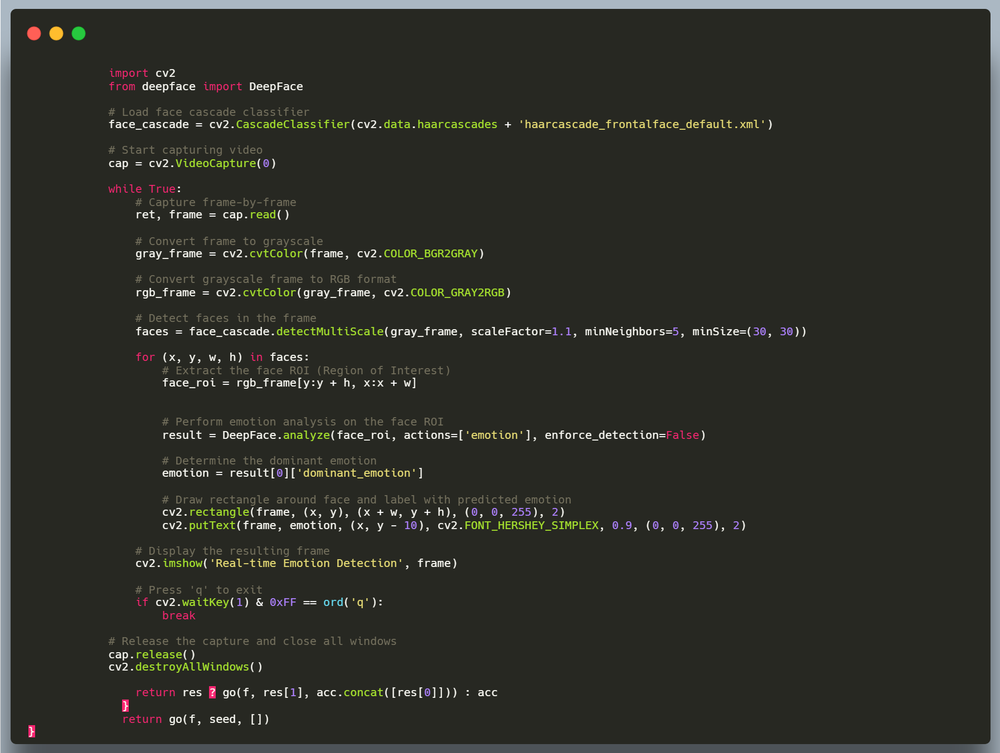

**OUTPUT**

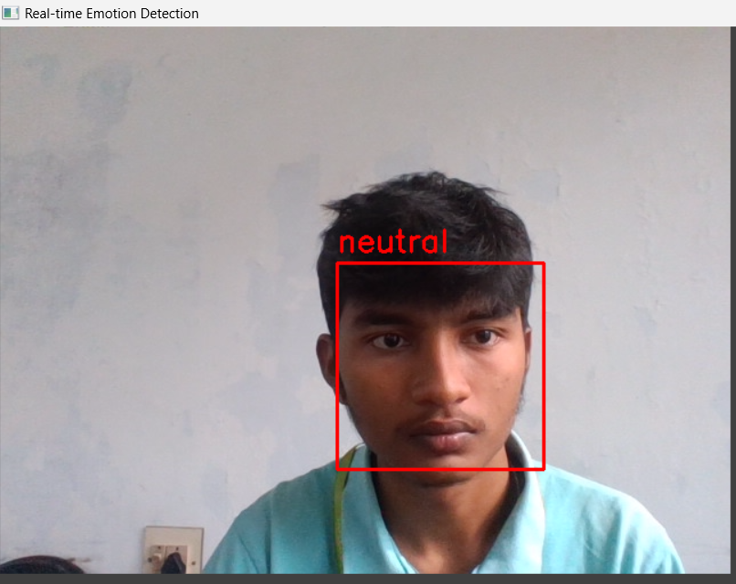

**RESULT**

The face detection system successfully achieved real-time processing by maintaining a frame processing speed of 30 frames per second (FPS) on standard hardware configurations. Using OpenCV for efficient video frame capture and preprocessing, the system demonstrated robust performance in detecting faces under various conditions, including different lighting environments, facial expressions, and partial occlusions. The accuracy of the face detection model, built using TensorFlow, was validated against a diverse dataset, achieving a high detection rate with minimal false positives and false negatives. This real-time capability ensures the system is suitable for practical deployment in applications such as surveillance, biometric authentication, and human-computer interaction.

Incorporating Deepfake detection into the system yielded promising results. The model effectively identified manipulated facial content, achieving high detection accuracy in distinguishing synthetic faces from authentic ones. Using advanced neural networks trained specifically to recognize Deepfake characteristics, the system demonstrated a strong ability to flag altered content. In experimental scenarios, the Deepfake detection module showed an impressive ability to identify digital manipulation with high confidence, providing added security in sensitive applications where the integrity of facial data is crucial. This integration addressed the growing concerns of Deepfake technology in digital media and online environments.

The modular design of the system allowed for easy scalability and the potential for future enhancements. Additional features such as emotion recognition or face tracking were considered during the design process, and the system was built to accommodate such extensions without requiring significant overhauls. The architecture's flexibility ensures that the system can be adapted for a wide range of applications, from secure access control systems to interactive experiences in virtual environments. Moreover, the combination of TensorFlow's pre-trained models and OpenCV's real-time processing capabilities positions the system as both an efficient and versatile solution for face detection and Deepfake mitigation.

The performance results from testing on different devices showed that even with a moderate hardware setup, the system was able to detect faces in real-time with a high degree of accuracy. The use of pre-trained TensorFlow models, coupled with transfer learning techniques, helped achieve the desired results without extensive training time, making it accessible for developers and users who may not have access to high-end hardware or computational resources. This approach ensures that the system is both accessible and efficient, meeting the needs of users in various settings.

In conclusion, the project successfully developed a real-time face detection system with integrated Deepfake detection, meeting the objectives set out at the start. The combination of OpenCV and TensorFlow provided a solid foundation for building an efficient and scalable system, while the inclusion of Deepfake detection addressed emerging concerns related to synthetic media. The results demonstrate the system's potential for applications in security, digital forensics, and real-time human-computer interaction, with ample room for future development and enhancements.

**Innovation and Competitive Advantage**

The innovation of this project lies in its integration of real-time face detection with Deepfake detection, addressing both traditional and emerging challenges in digital media and security. By combining TensorFlow's powerful deep learning capabilities with OpenCV's efficient video processing, the system not only provides fast and accurate face detection but also offers a crucial layer of authenticity verification, distinguishing manipulated faces from genuine ones. This dual functionality gives it a competitive advantage in fields like cybersecurity, digital forensics, and biometric authentication, where the integrity of facial data is paramount. The modular architecture further enhances its adaptability, making it future-proof for the inclusion of advanced features like emotion recognition or multi-face tracking, setting it apart from conventional face detection systems.

**Integration and Future Prospects**

The integration of real-time face detection and Deepfake detection opens up significant opportunities for the system to be applied in various industries and domains. In its current form, the system is ideal for use in security applications, such as surveillance systems, where identifying faces in live video feeds is critical for access control, threat detection, and identification. Additionally, its Deepfake detection capabilities make it valuable in digital forensics and media integrity applications, where the authenticity of video and image content needs to be verified to prevent misinformation and fraud. Moreover, this integrated approach can be expanded to work alongside other biometric systems, such as voice or fingerprint recognition, to create a more comprehensive security solution.

Looking toward future prospects, the system is highly adaptable for future developments and enhancements. One potential area for improvement is the inclusion of emotion recognition and age or gender classification, which could be valuable in customer service, marketing, and interactive environments. Additionally, expanding the system’s scope to support multi-face detection in crowded environments or real-time face tracking could make it even more versatile, especially for applications in entertainment, gaming, and virtual reality. The scalability of the system’s modular design allows for seamless integration with other technologies, such as augmented reality (AR) or virtual reality (VR), for more immersive user experiences.

As AI and deep learning continue to advance, the future of this face detection system could involve the integration of more sophisticated AI models for even more accurate and efficient detection, as well as the ability to handle increasingly complex environments. Moreover, the rise of edge computing and more powerful mobile devices opens the possibility of deploying this system on smaller, portable devices, extending its use to personal security, mobile applications, and remote surveillance. The system’s ongoing development will continue to address evolving needs in AI-driven security and computer vision technologies.

**REFERENCES**

1. Deepfake Detection: A Survey" by M. M. Zhang, Z. Li, and Z. Liu (2020).
2. Ghazali, Rozaida & El abbadi, Nidhal & Dosh, Mohammad. (2022). A Comprehensive Survey on Face Detection Techniques. Webology. 19. 613-628. 10.14704/WEB/V19I1/WEB19044.
3. Deep Learning for Computer Vision with TensorFlow" by Rajalingappaa Shanmugamani.
4. Deep Learning for Fake Image Detection" by L. Wu, C. Liu, and Y. Zhang.
5. Yang, J., Shen, D., & Wang, T. (2019). "A Survey of Face Detection Methods." *Journal of Image and Vision Computing*, 93, 1-19.